- Touch sensor pattern size of 7” capacitive touch panel(EELY): 11.77x9.18mm, so it’s better to design graphic icon or touch button size bigger than 11.77x9.18mm.
Notes: Red line is centre of touch sensor pattern.
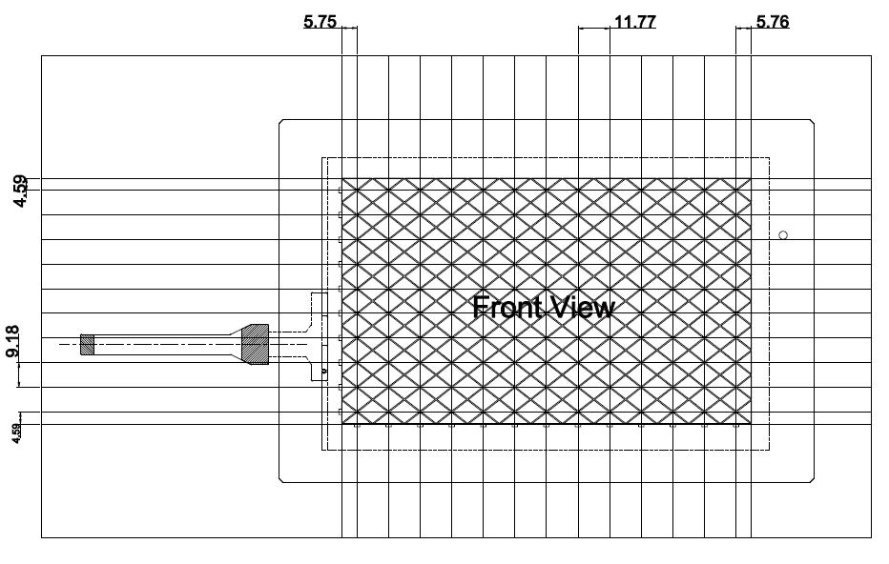

- Central position of graphic ICON shall be placed directly on central position of touch sensor pattern, i.e. diamond pattern on the drawing below.
Notes: Refer to red line indicated the horizontal/vertical central position of big or small size graphic icon.
即图片或者按键要尽可能放在触摸感应菱形图案的中心位置，参考图中红色箭头，不论是水平或者垂直方向。这样可以减少误操作。
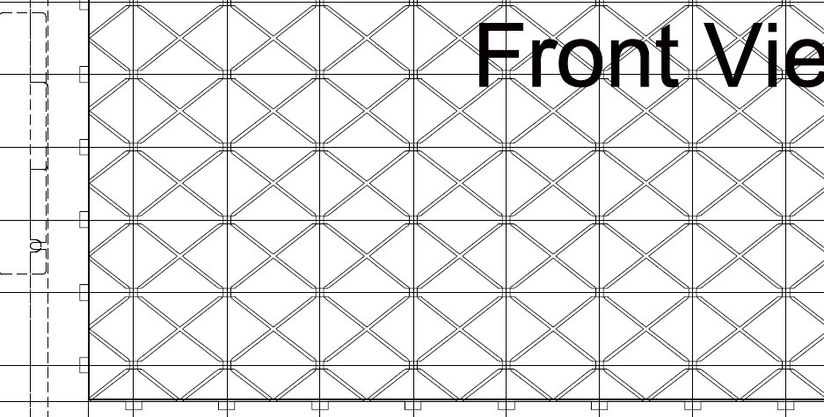



Better area for touch???

- Below position of Graphic ICON position shall be right on position of touch sensor pattern, i.e. diamond pattern on the drawing below.
Notes: Refer to position of small size graphic icon.

- Every sensor’s coordinate shall be identified on the drawing below.
LCD可视区物理尺寸：152.4mm x 91.44mm, 对应屏幕上的像素坐标800x480

(X轴方向)
30
92
154
216
278
340
401
462
524
586
648
710
771
24
72
120
168
217
265
313
361
409
457

